ASSIGNMENT-2

TASK: Create 3 VPC’S and connect them using Transit Gateway

* Search for vpc in search bar of AWS home page and click on vpc under services

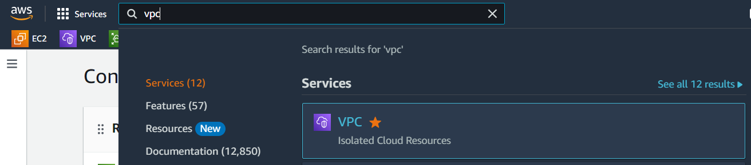

* Click on Your VPCs option under Virtual private cloud and Click on Create VPC

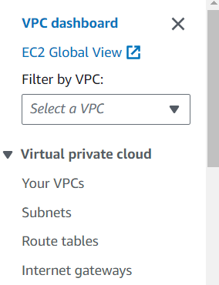

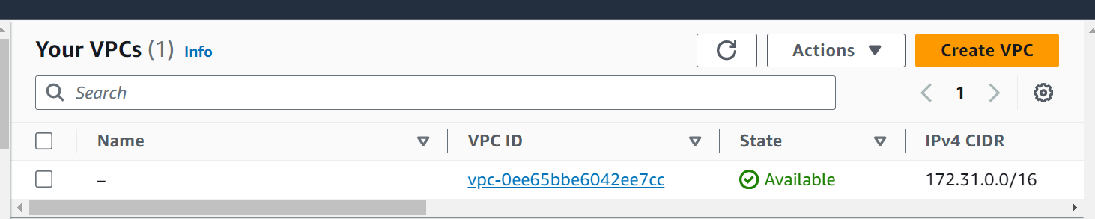

* Fill details like name and IPv4 CIDR and click on Create VPC button (here I have named my VPC as my vpc-1 and CIDR is 13.0.0.0/16)

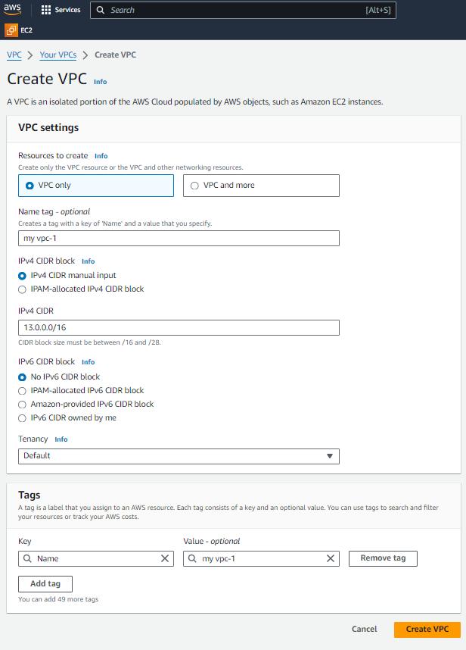

* Now Create 2 more VPCs in same way (name second VPC as My VPC-2, give IPv4 CIDR as 14.0.0.0/16 and name third VPC as My VPC-3 and IPv4 CIDR is 15.0.0.0/16)

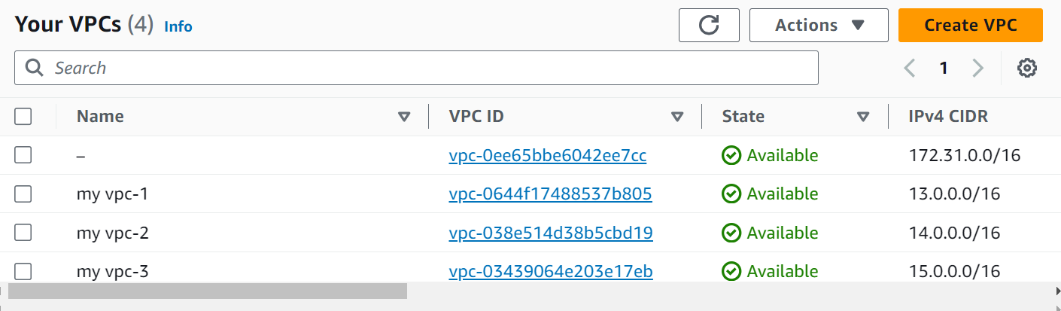

* Now we have to create 3 subnets as we have 3vpc’s. So, click on Subnets option under virtual private cloud and click on Create Subnets.

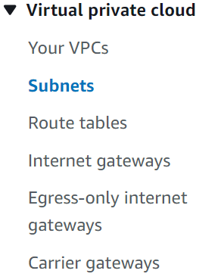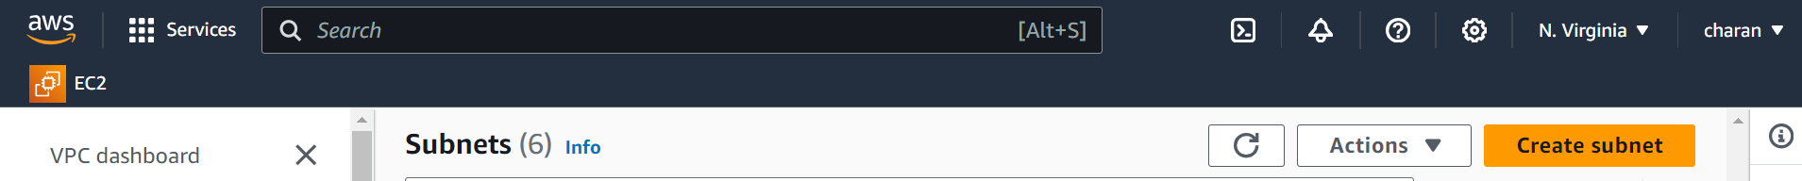

* Under VPC ID, select our VPC1 from drop down and under Subnet settings, name the subnet (my subnet-1), select the Availability Zone (us-east-1a) and give CIDR in IPv4 subnet CIDR block (13.0.0.0/24) and finally click on Create subnet button.

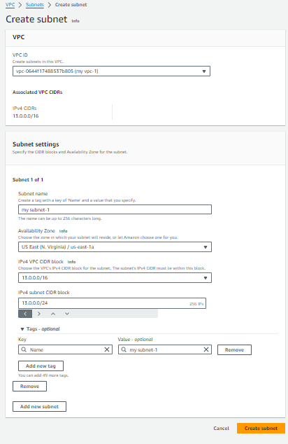

* Create two more subnets :
* select VPC2 for second subnet and name it as my subnet-2, select AZ as us-east-1b, IPv4 subnet CIDR is 14.0.0.0/24
* select VPC3 for third subnet and name it as my subnet-3, select AZ as us-east-1c, IPv4 subnet CIDR is 15.0.0.0/24
* These are the three subnets that we have created.

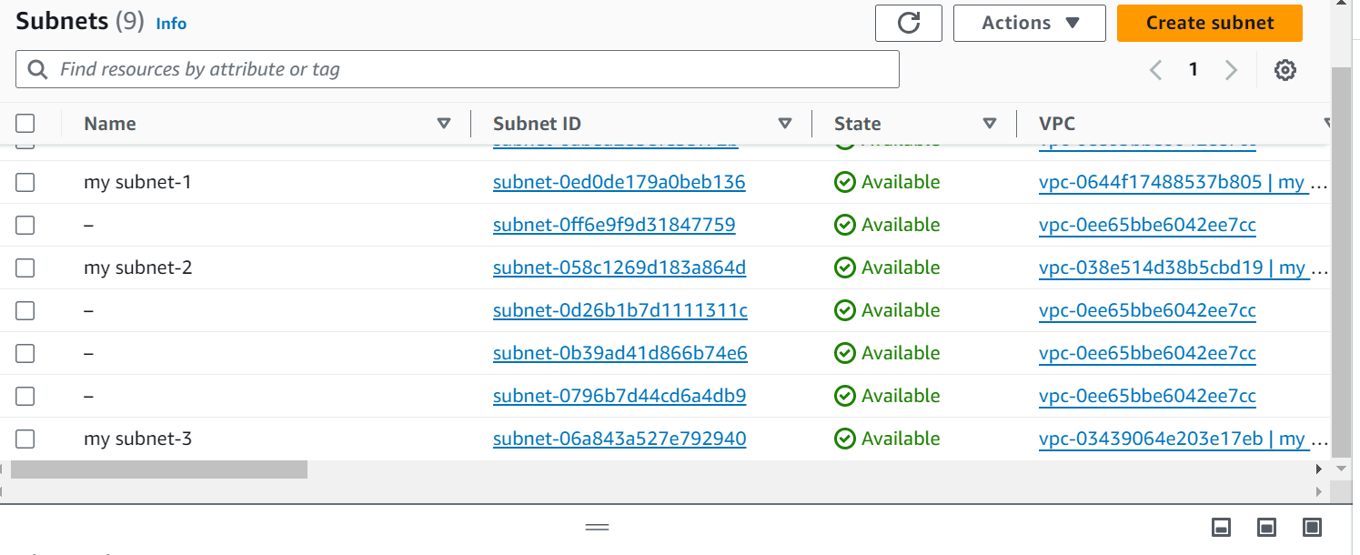

* Now create 3 route tables for three subnets.
* Click on Route tables under Virtual private cloud and click on Create route table button.

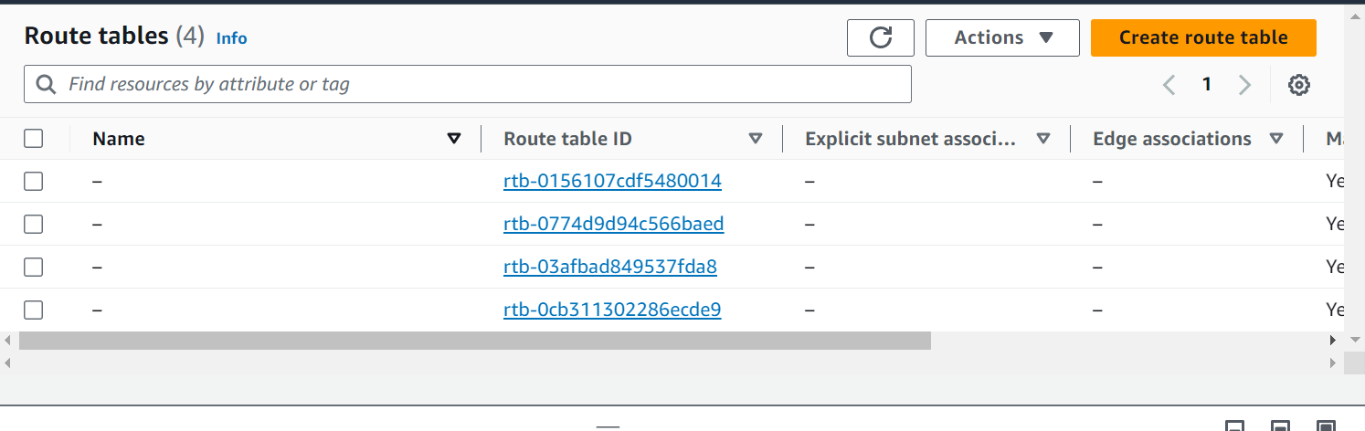

* Name our route table as My route-1 and select our VPC1 under VPC form drop down and finally click on Create route table.

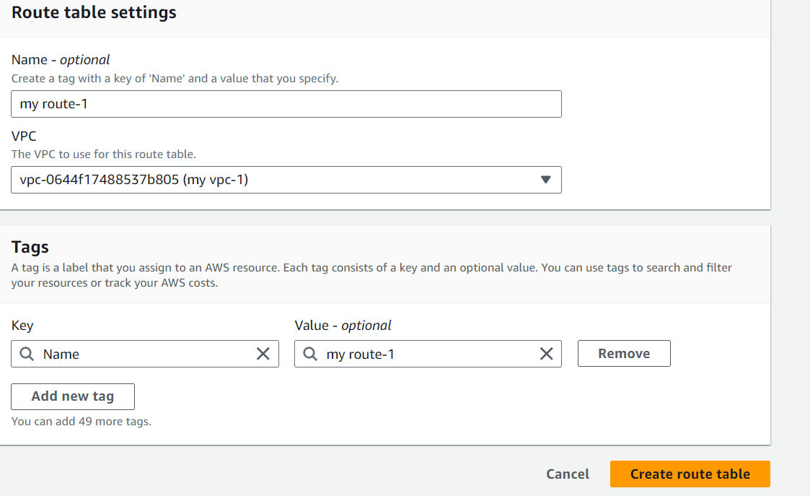

* Create 2 more rote tables:
* For second route table give name as My route-2 and select VPC2.
* For third one, name it as My route-3 and select VPC3.

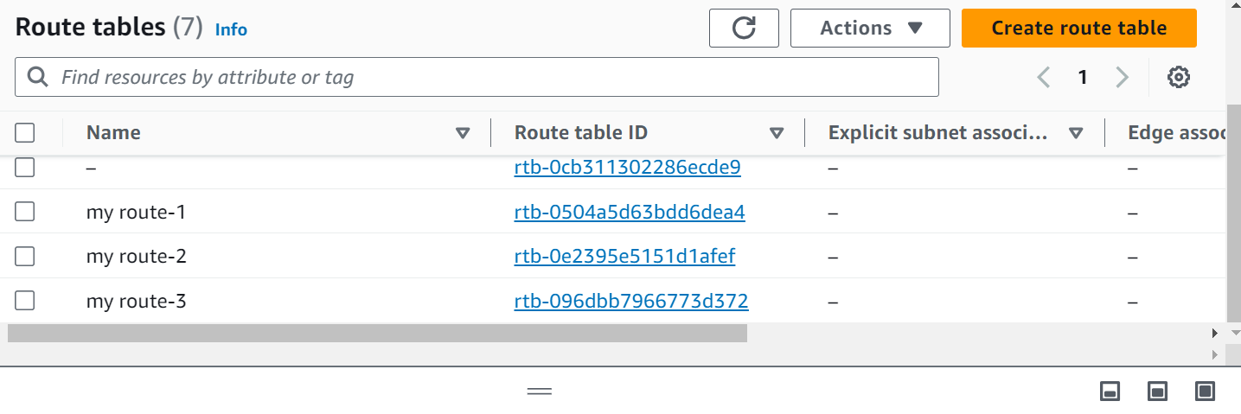

* Now we have to create 3 Internet Gateways as we have 3 VPCs. So, click on Internet gateways option under virtual private cloud and click on Create internet gateway button.

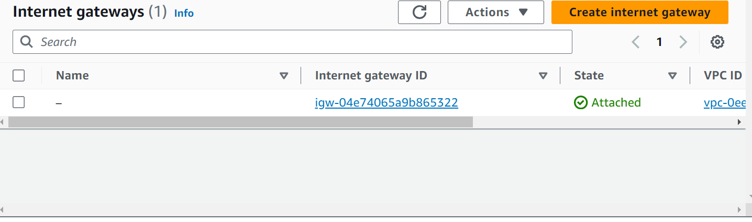

* Give any name to our Internet gateway as My igw-1 and click on Create internet gateway.

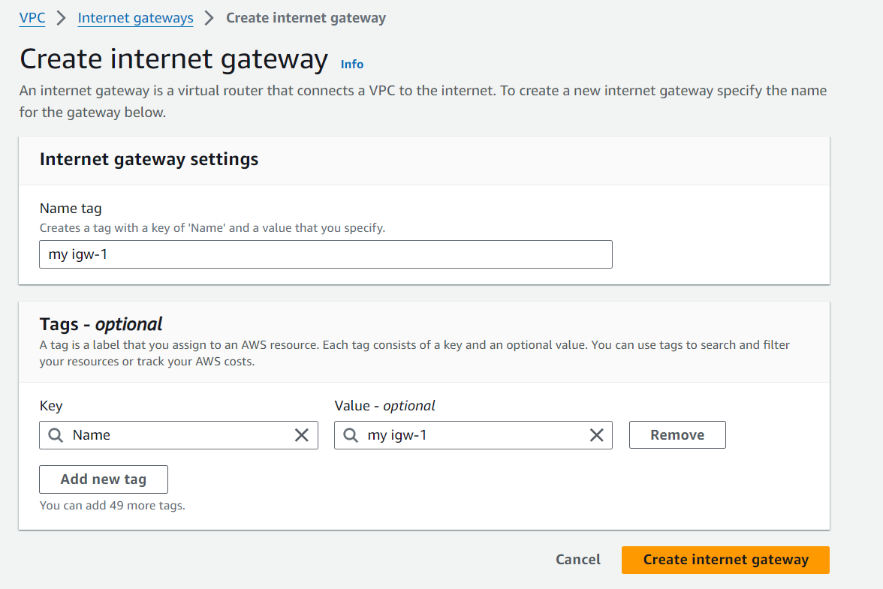

* Create 2 more Internet gateways in the same way (for second Internet gateway give name as My igw-2, and for third one give name as My igw-3).
* Now we have to attach our internet gateways with our VPCs.
* So, select My igw-1 🡪 click on Actions and click on Attach to VPC 🡪 Select our VPC1 and finally click on Attach internet gateway.

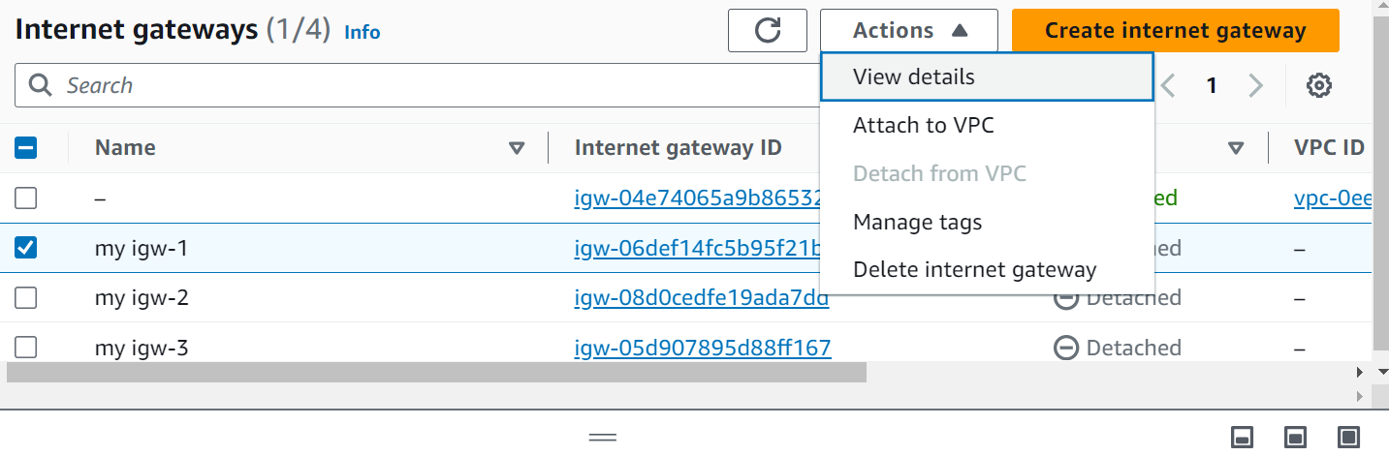

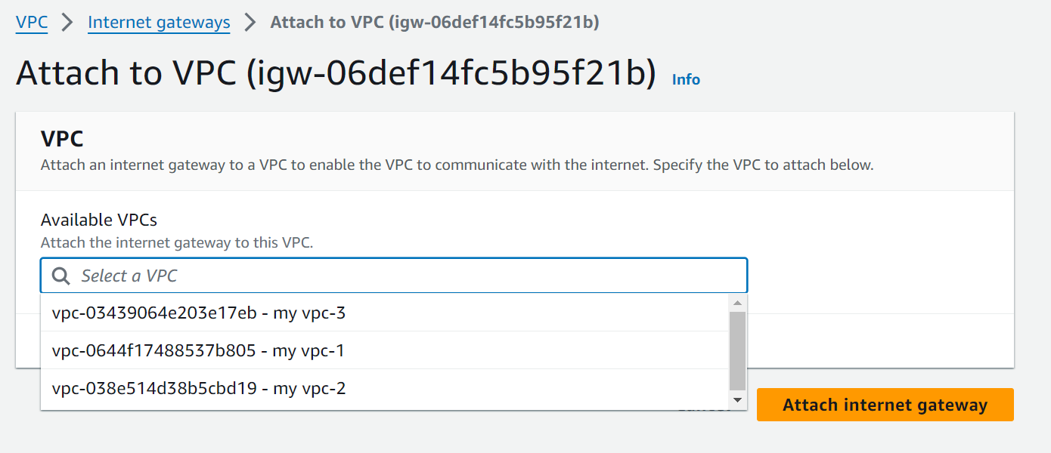

* Now do the same for remaining Internet gateways. Select My igw-2 and attach it with VPC2 and My igw-3 with VPC3.
* Now go to Internet gateways and we can see our internet gateways in Attached state.

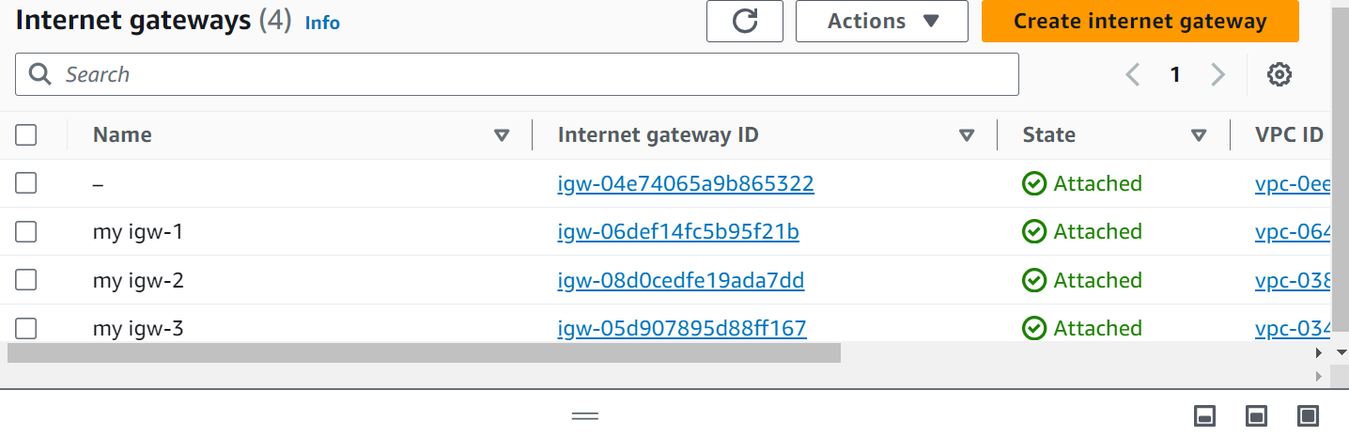

* Now go to route tables. Click on My route-1 , click on Subnet associations and click on Edit subnet associations.

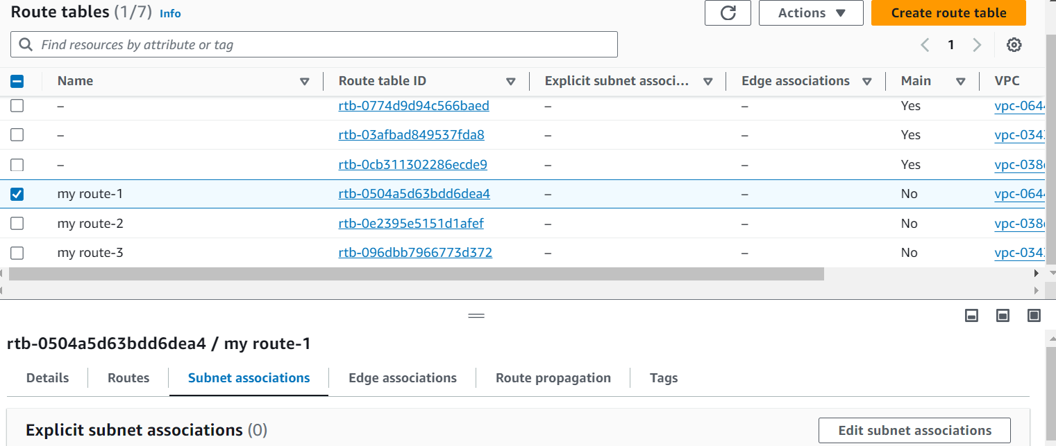

* Select My subnet-1 and click on Save associations button.

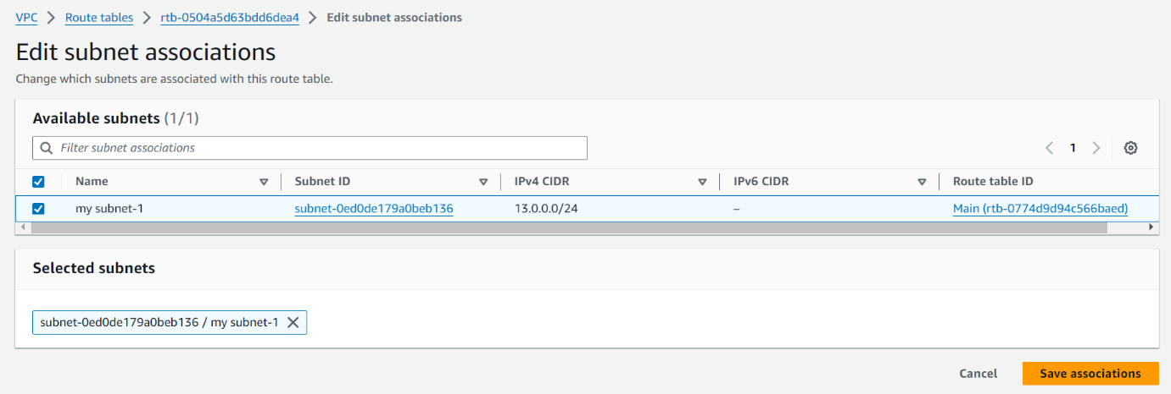

* Now click on Actions and click on Edit routes.

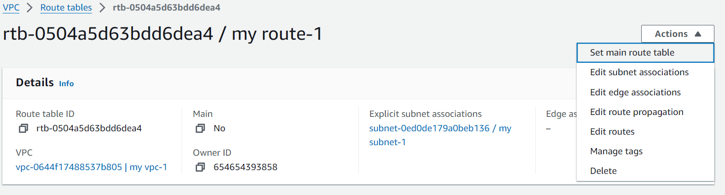

* Click on Add route, give 0.0.0.0/0 as Destination and select Internet gateway from drop down under Target and select our My igw-1 and finally click on Save changes button.
* Now repeat same process for remaining two routes also.
* Now we have to create Transit Gateway, for that click on Transit gateways and click on Create transit gateway.

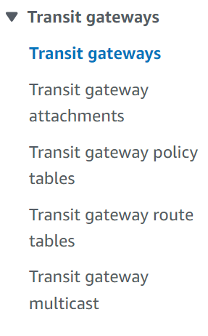

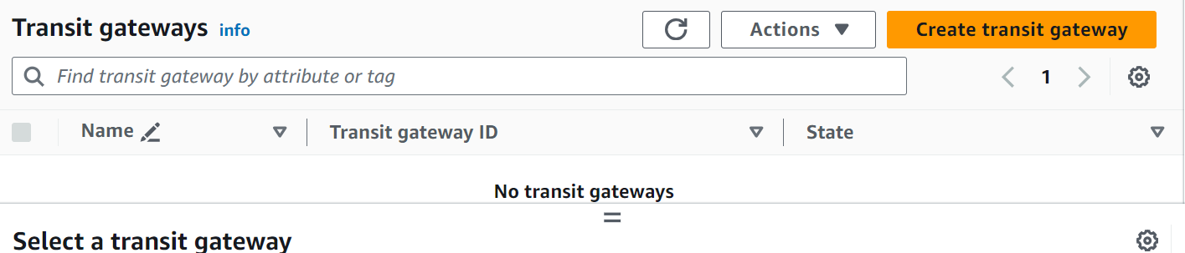

* Name our Transit gateway as my-TGW, give Description as nothing and click on Create transit gateway.

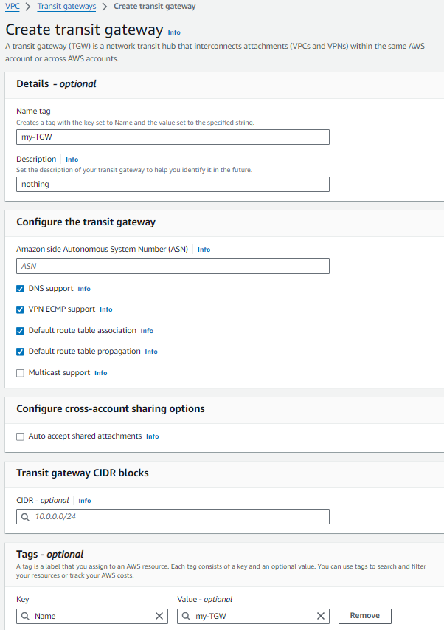

* Now click on Transit gateway attachments and click on Create transit gateway attachment.

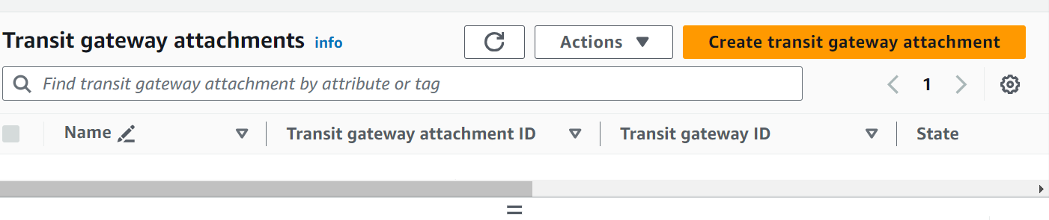

* Give name to attachment My transit attach-1, under Transit gateway ID, select our Transit gateway that we already created My-TGW. Under VPC ID, select our My vpc-1 and finally click on Create transit gateway attachment.

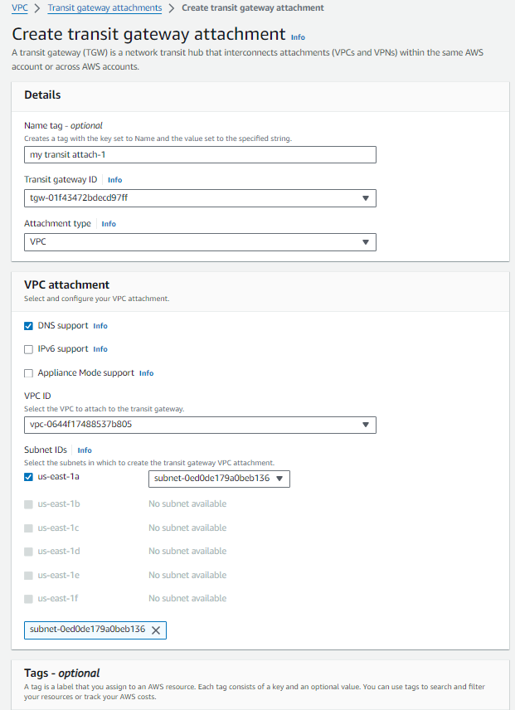

* Now repeat the same process for remaining two transit gateway attachments same as above.
* We can observe now that we have created three transit gateway attachments.

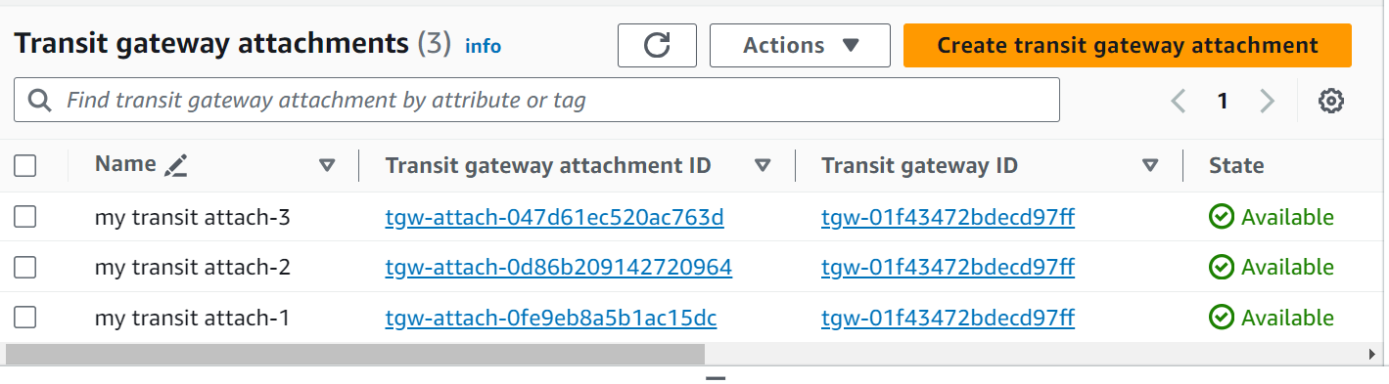

* Go to route tables, go to first route table (My route-1), click on Actions, click on Edit routes.

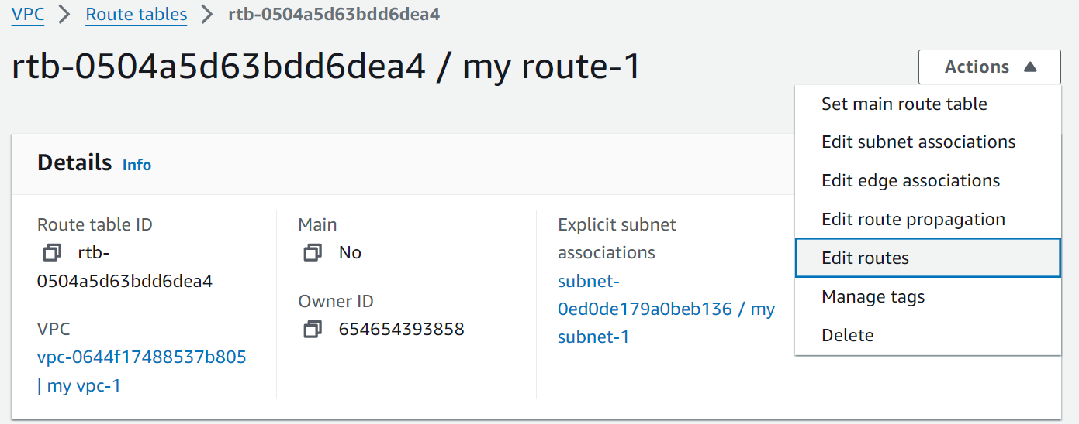

* First click on Add route, give Destination as 14.0.0.0/16, under Target, select Transit Gateway form drop down and select our Transit gateway attachment (My transit attach-1). Again click on Add route, give Destination as 15.0.0.0/16, select Transit Gateway form drop down as Target and select our Transit gateway attachment (My transit attach-1). Finally click on Save changes.

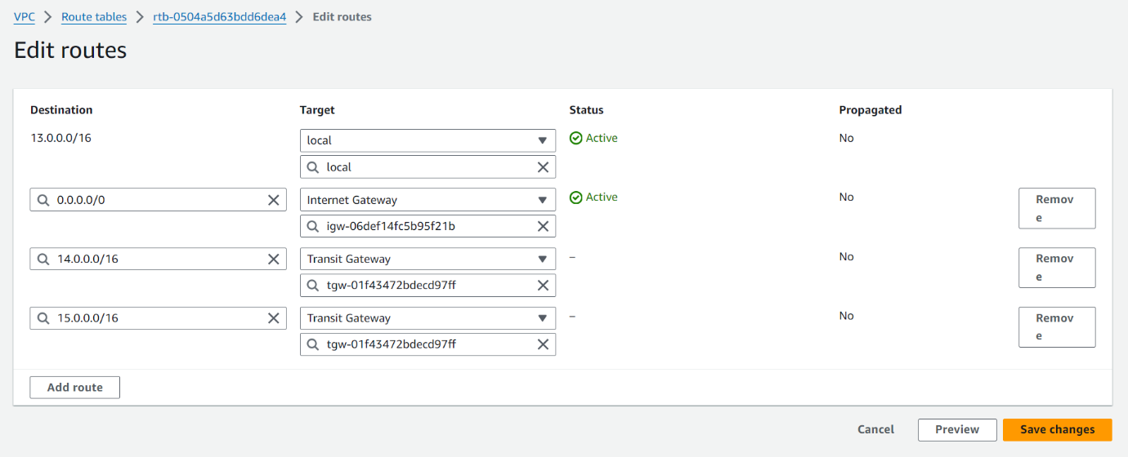

* NOTE: Here we are in route table one (my route-1), and its Destination is 13.0.0.0/16. So, we have to give another two IPv4 addresses as Destinations.
* Now repeat the same process for remaining two routes. If its destination is 14.0.0.0/16 then we need to give another two IPV4 addresses as Destinations.
* We are going to launch three EC2 instances.
* On Search for EC2 in search bar in AWS home page, click on EC2 under Services. And click instances form menu and click Launch instance.

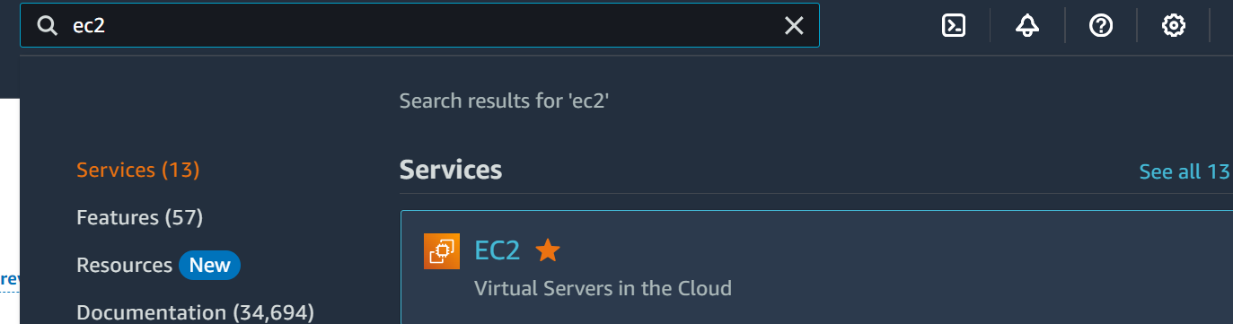

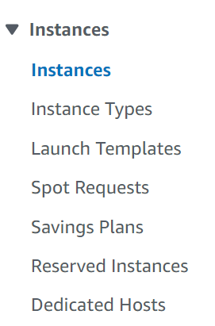

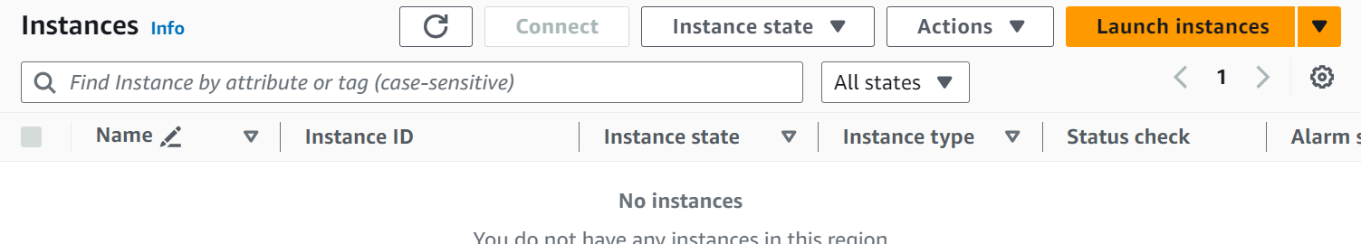

* Give any name to our instance as My-EC1. Select OS of your choice (I have selected Amazon Linux) and instance type as t2.micro.

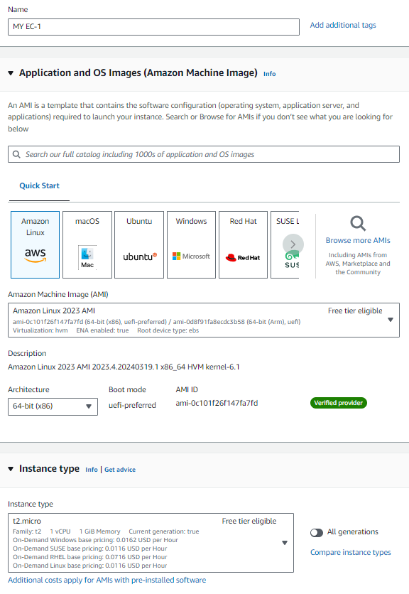

* We have to create a key pair. So, click on Create new key pair option. Give name to our key pair and click on Create key pair button.
* In Network settings area, click on Edit button to configure with our custom VPCs.
* Under VPC section, select our My VPC-1. Enable Auto-assign public IP. Select Create security group (if we already have a security group, we can select, Select existing security group option)



* Now click on launch instance.
* Repeat the same process for two more instances.
* Go to instance one (MY EC-1), scroll down and click on Security. Now click on the link under Security groups.

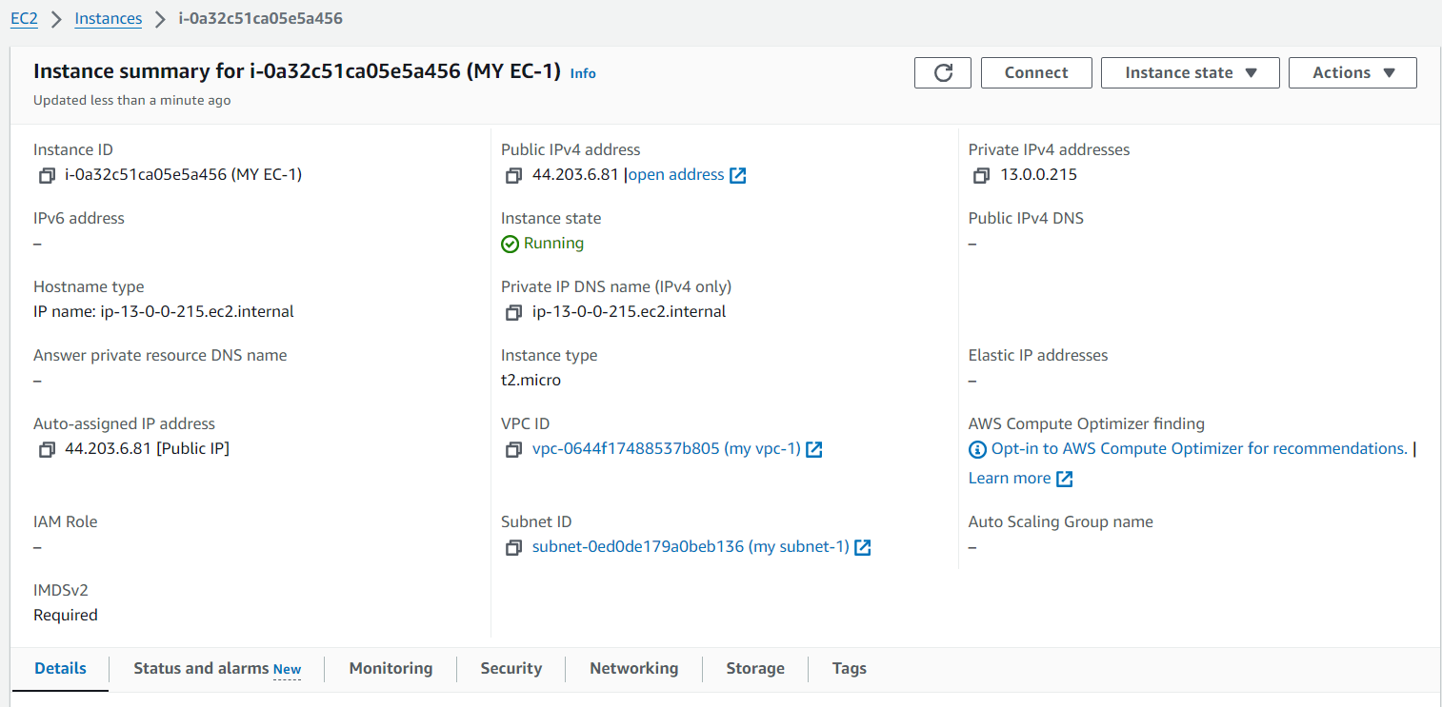

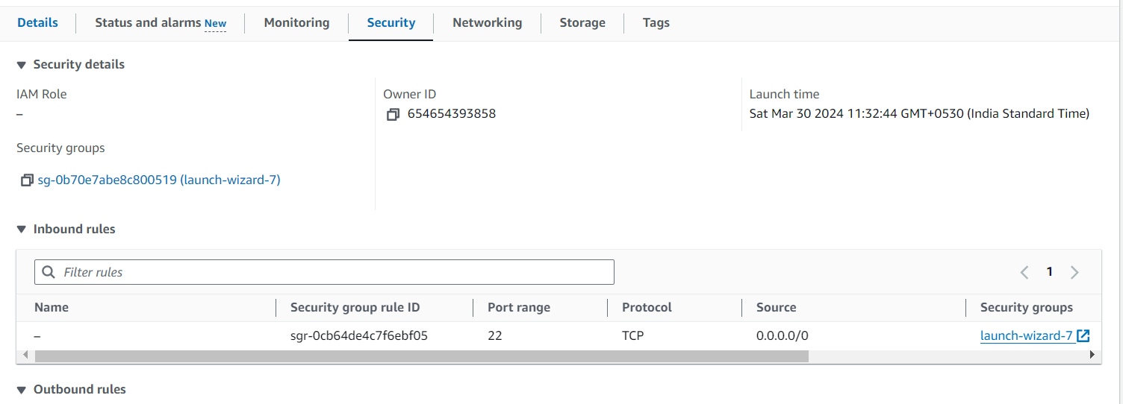

* Click on Actions, click on Edit inbound rules.

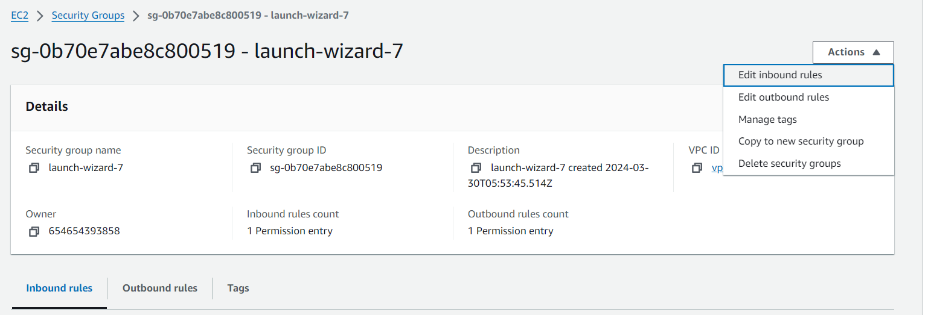

* Click on Add rule, select all traffic instead of Custom TCP. Give 14.0.0.0/16 as Source. Add one more rule for HTTP and give source as 15.0.0.0/16. And click on save rules.

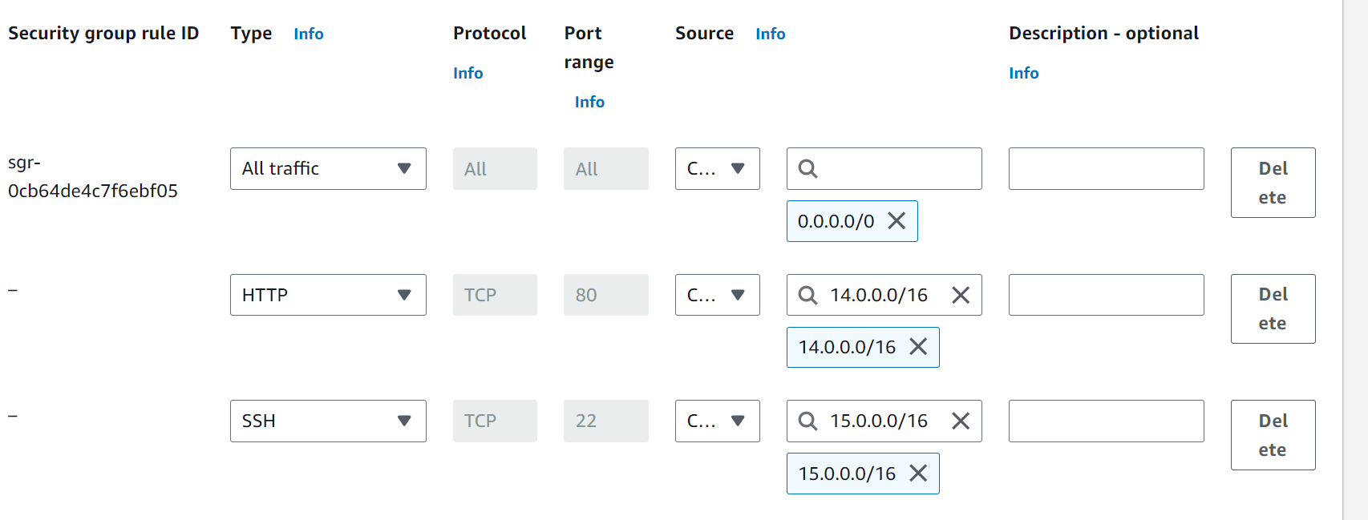

* Now go to second instance and do the same things. (add two rules with HTTP, one for source 13.0.0.0/16 and another one is for 15.0.0.0/16) and Save rules.
* Now go to third instance and do the same things. (add two rules with HTTP, one for source 13.0.0.0/16 and another one is for 14.0.0.0/16) and save rules.

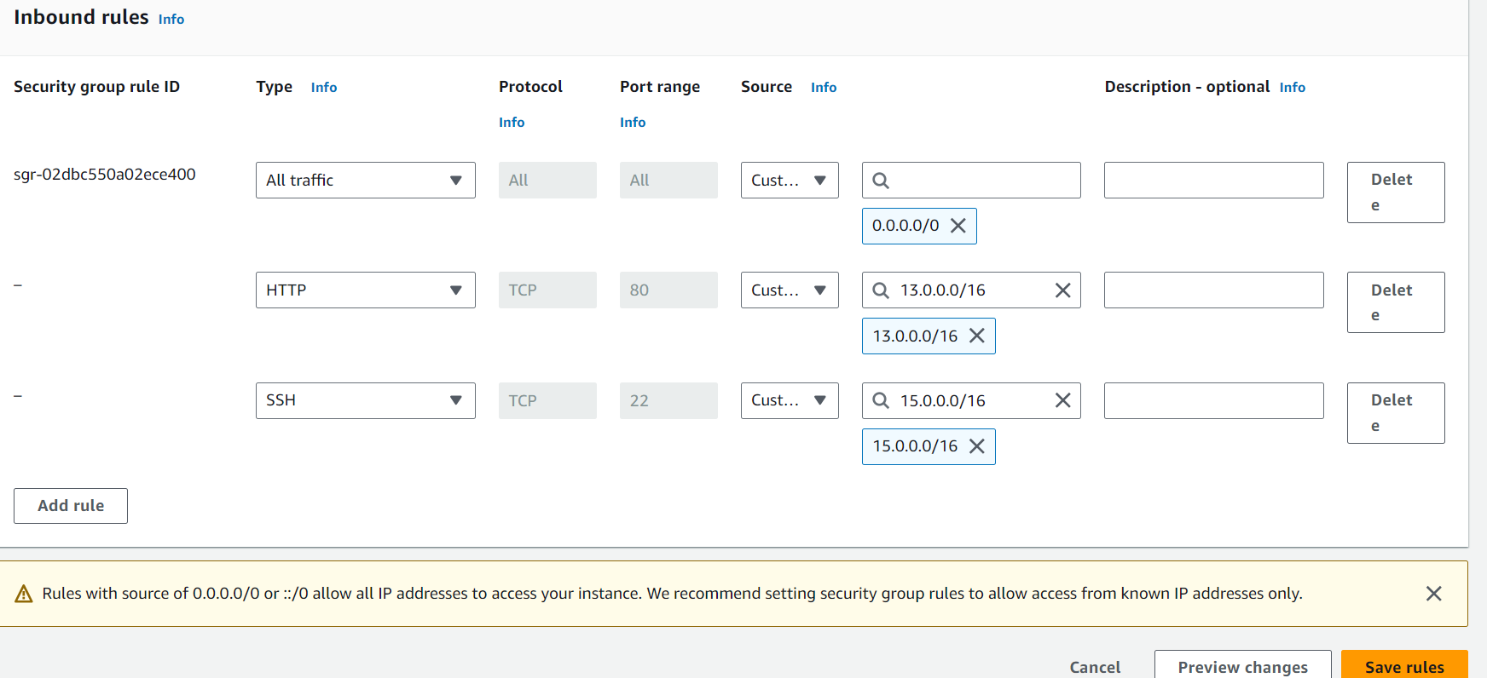

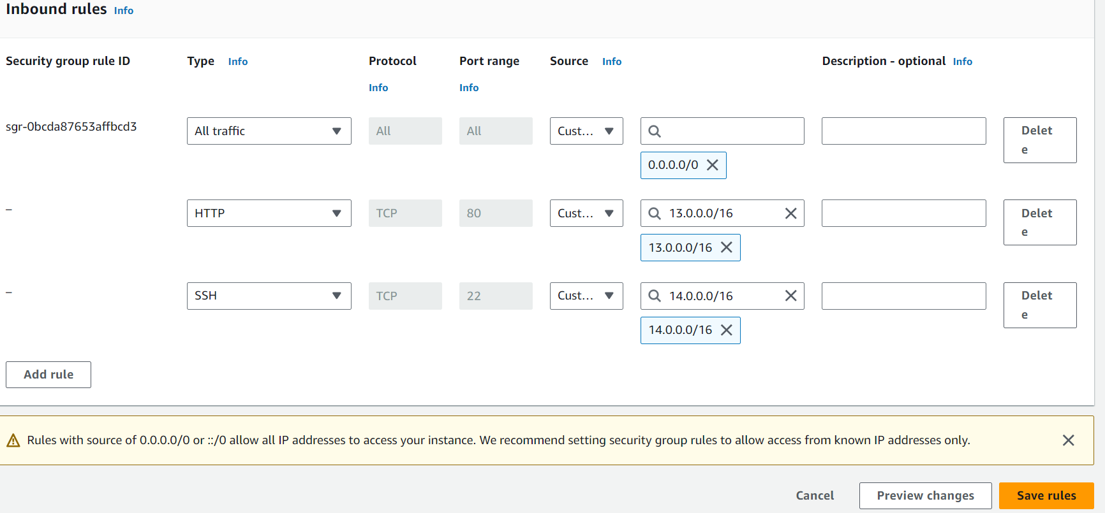

* We have to connect the instances one by one.
* Go to instances, select first instance (MY-EC1) and click on connect option and finally click on Connect.

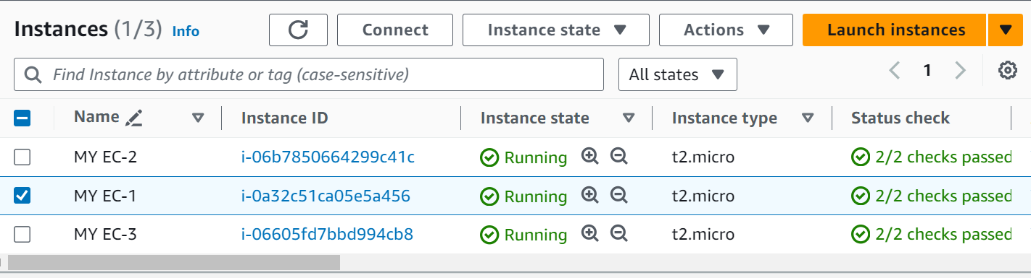

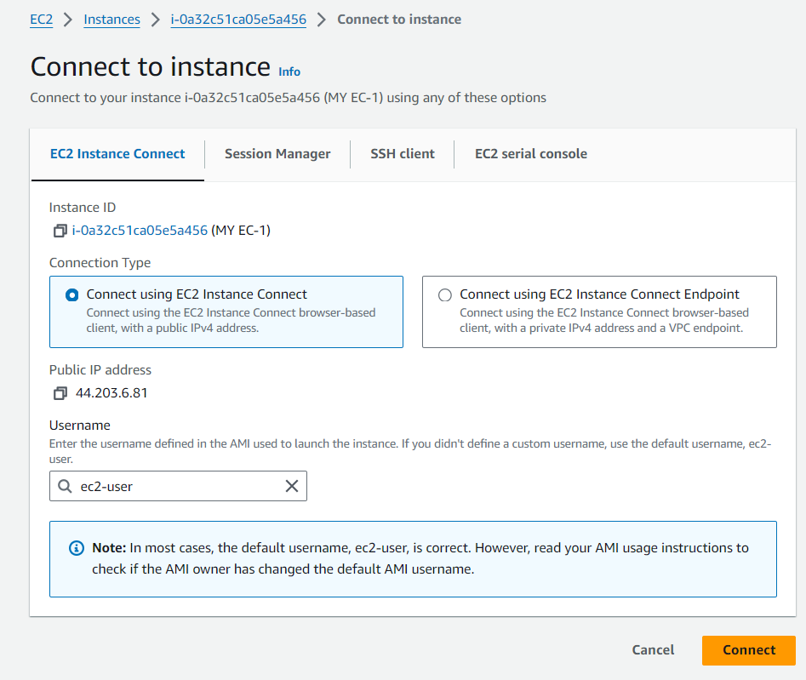

* After successful connection of our instance (server), give sudo -i to change to root user.

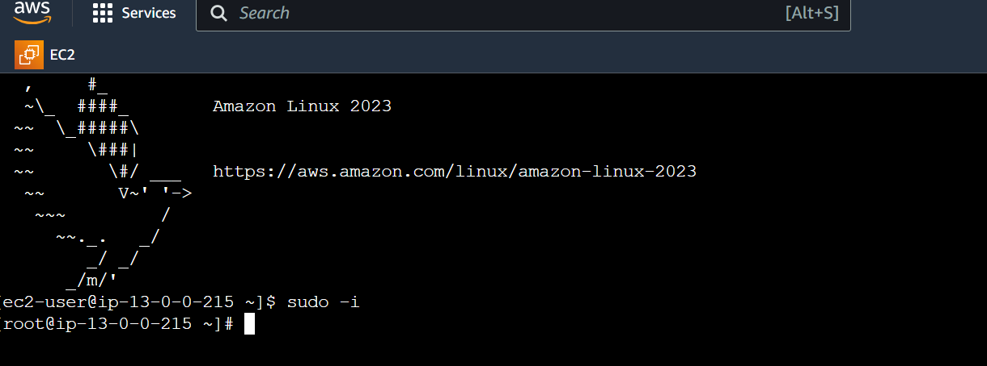

* I’m going to install nginx in connected server

🡪yum update –y

🡪yum install nginx –y

* After successful installation, will get below

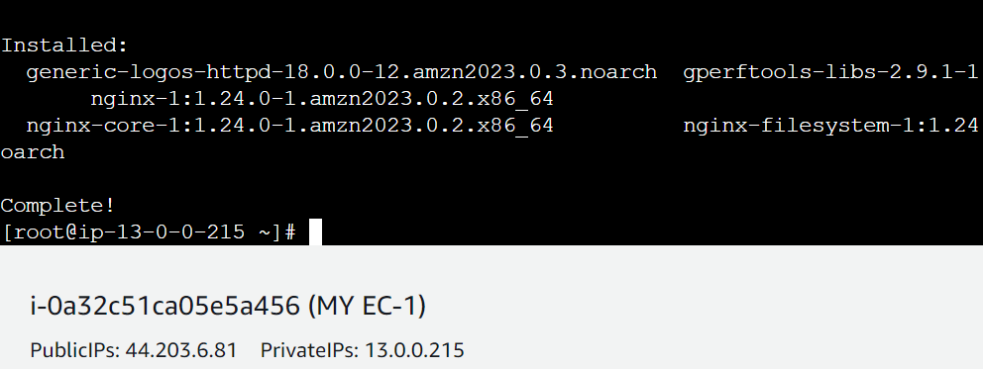

* Now go to /usr/share/nginx/html path, there we have index.html file. Please remove it and create the same file (index.html) with our own content. And save the file.

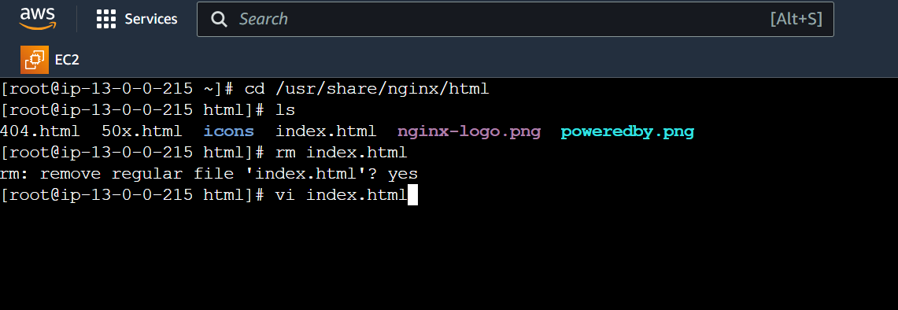

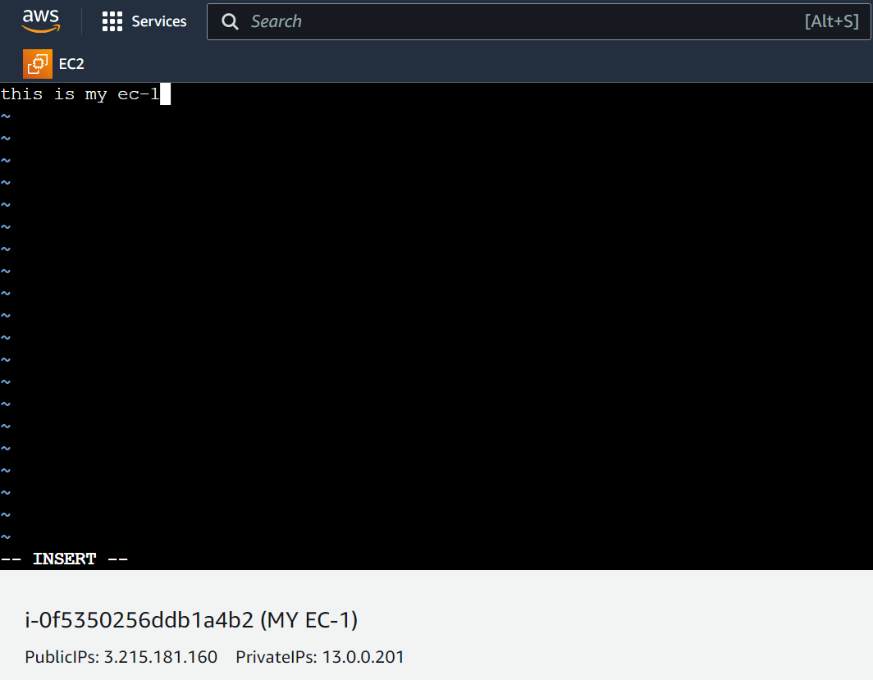

* Now restart nginx with following command
* Systemctl restart nginx
* Now copy the public IP of connected server and use below command to see the connect in the index.html file
* Curl 13.0.0.0201:80(see the below pic for clarity)

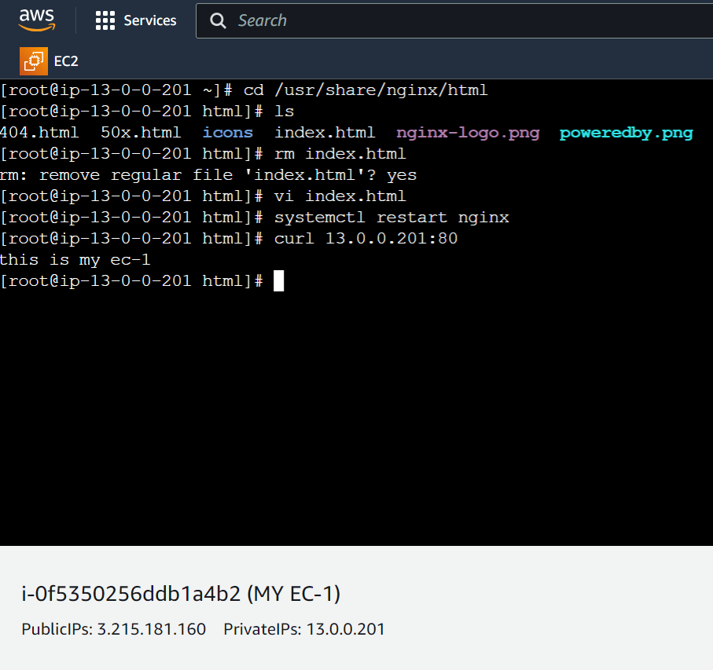

* Now connect to second instance (MY-EC2) and follow same process and commands (in index.html, type This is my instance2). Refer below pic

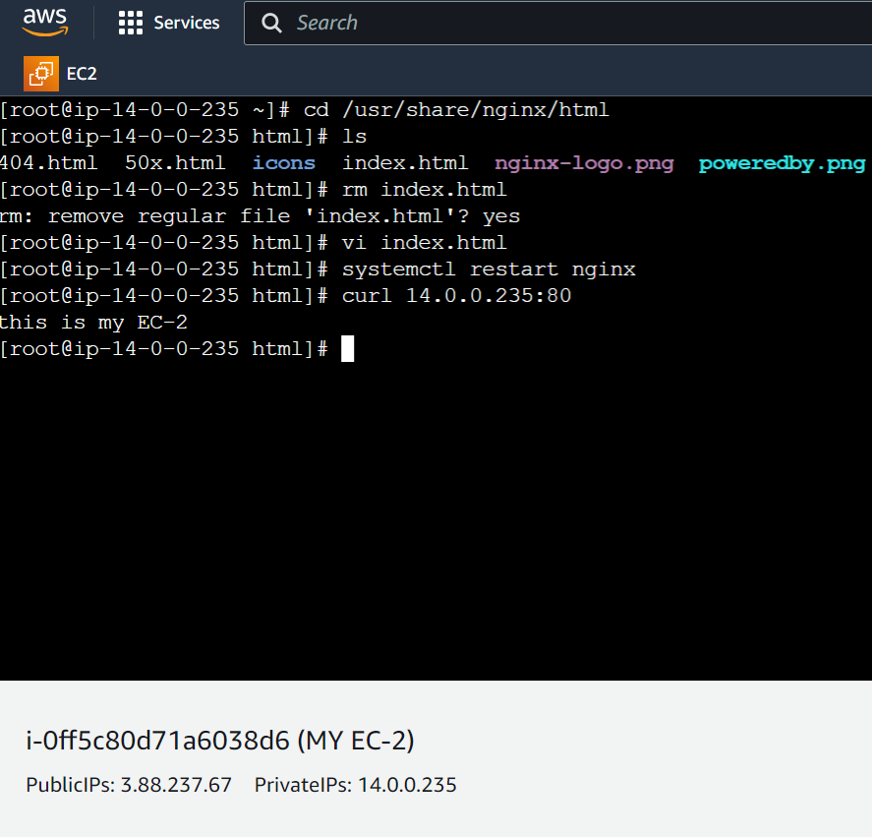

* Now connect to third instance (VPC3-EC2) and follow same process and commands (in index.html, type This is my instance3). Refer below pic

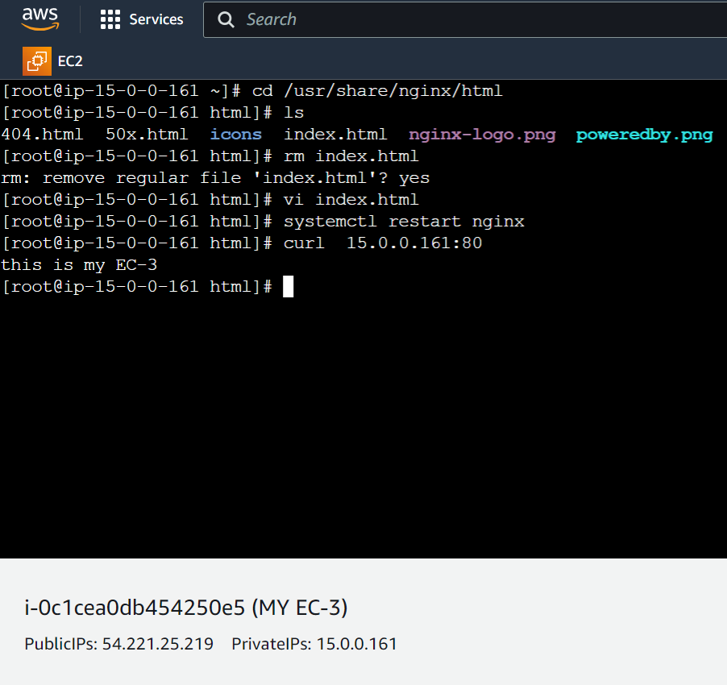

* Now copy the private IP of any connected instance and go to another connected instance (for example I have copied IP of instance three i.e. our MY-EC3 and paste that IP in second instance i.e. our MY-EC2) and use curl command. Refer below pic

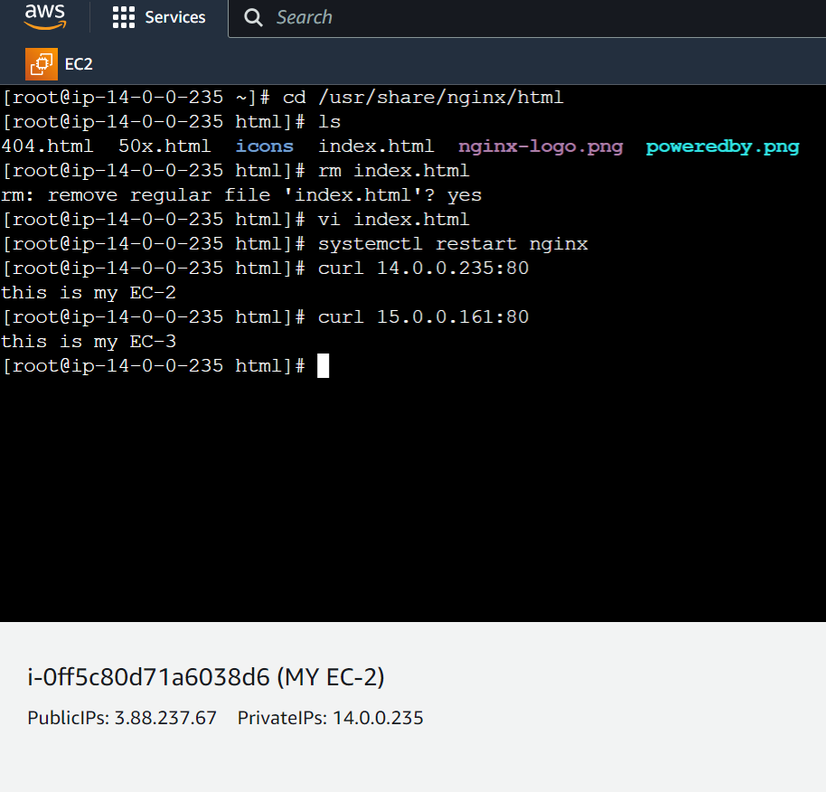

* If we observe above pic, I have copied the private IP of instance3 and pasted on instance2. And after using curl command we got – This is my EC-3 content/message in instance 2 (MY-EC2).
* So our Transit gateway task successfully completed.